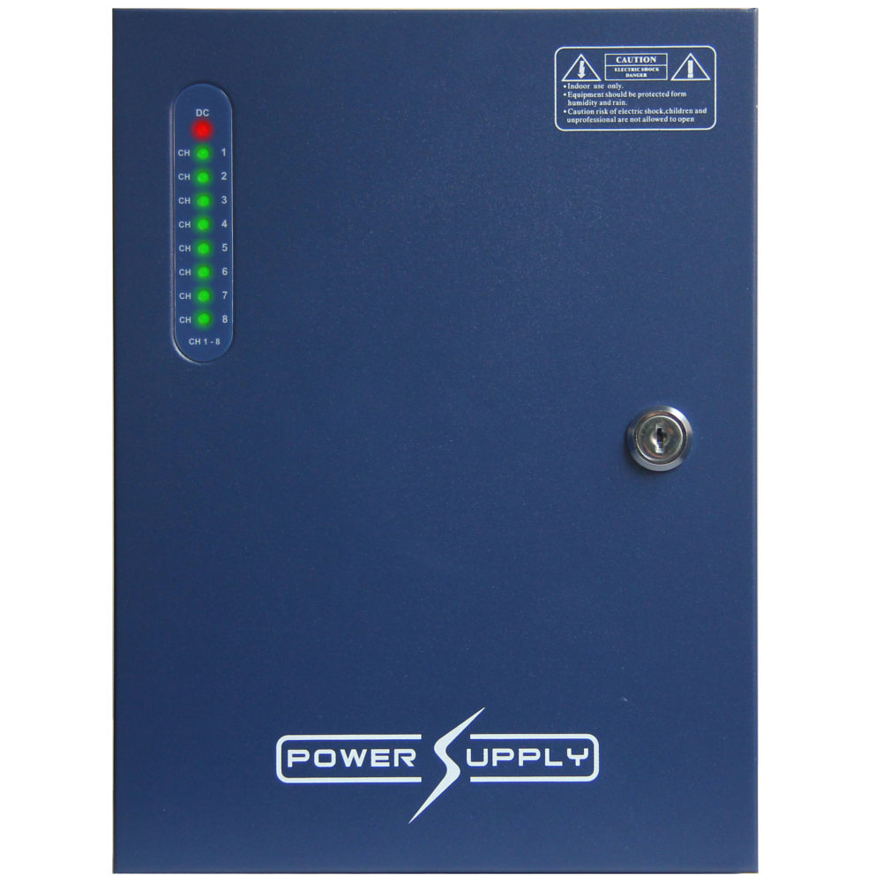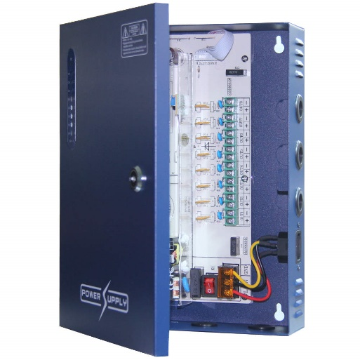

Photo M097 M097at

Product Code PSP8LED

8 port LED Power Box

8 port 12v DC, 8amp, PTC auto resetting overloads, Locking Front door with status LEDs

This power supply with locking hinged front door provides a professional solution for multi-camera installations. Wall mounting with strong steel enclosure, it provides a neat and fully organized solution. It includes 8 individual 1 amp outputs with PTC auto resetting overloads which are monitored by front panel mounted LED indicator lights for easy output status indication. The 12-15volt adjustable output voltage can be provides a solution for volt drop over long cable distances giving you the ability to run power over greater distances.

8 x 1 amp screw terminal outputs with auto-resetting PTC overload cutouts
8 amps total maximum output
8 x output status LED indicators mounted on front panel
12-15 volt DC adjustable voltage output, provides adjustment for long cable volt drop
Lockable hinged front door
Wall mountable metal enclosure
Multiple cable entries
Kettle lead with 13 amp plug electrical connection (no electrical installation cert required)
Small compact size H220 x W180 x D65mm
Weight 1.2kg

Public £28.00 + VAT

Trade £26.00 + VAT

Key Cust £25.00

Distributer £22.00

